Collect, Readings and Prayers for the Third Sunday after Trinity
Collect

Almighty God,
you have broken the tyranny of sin
and have sent the Spirit of your Son into our hearts
whereby we call you Father:
give us grace to dedicate our freedom to your service,
that we and all creation may be brought
to the glorious liberty of the children of God;
through Jesus Christ your Son our Lord,
who is alive and reigns with you,
in the unity of the Holy Spirit,
one God, now and for ever.

Readings

Jeremiah 20:7-13

Jeremiah Denounces His Persecutors

⁷ O Lord, you have enticed me,
and I was enticed;
you have overpowered me,
and you have prevailed.
I have become a laughing-stock all day long;
everyone mocks me.
⁸ For whenever I speak, I must cry out,
I must shout, ‘Violence and destruction!’
For the word of the Lord has become for me
a reproach and derision all day long.
⁹ If I say, ‘I will not mention him,
or speak any more in his name’,
then within me there is something like a burning fire
shut up in my bones;
I am weary with holding it in,
and I cannot.
¹⁰ For I hear many whispering:
‘Terror is all around!
Denounce him! Let us denounce him!’
All my close friends
are watching for me to stumble.
‘Perhaps he can be enticed,
and we can prevail against him,
and take our revenge on him.’
¹¹ But the Lord is with me like a dread warrior;
therefore my persecutors will stumble,
and they will not prevail.
They will be greatly shamed,
for they will not succeed.
Their eternal dishonour
will never be forgotten.
¹² O Lord of hosts, you test the righteous,
you see the heart and the mind;
let me see your retribution upon them,
for to you I have committed my cause.
¹³ Sing to the Lord;
praise the Lord!
For he has delivered the life of the needy
from the hands of evildoers.

or Genesis 21: 8-21
Hagar and Ishmael Sent Away
⁸ Isaac grew, and was weaned; and Abraham made a great feast on the day that Isaac was weaned. ⁹ But Sarah saw the son of Hagar the Egyptian, whom she had borne to Abraham, playing with her son Isaac. ¹⁰ So she said to Abraham, ‘Cast out this slave woman with her son; for the son of this slave woman shall not inherit along with my son Isaac.’ ¹¹ The matter was very distressing to Abraham on account of his son. ¹² But God said to Abraham, ‘Do not be distressed because of the boy and because of your slave woman; whatever Sarah says to you, do as she tells you, for it is through Isaac that offspring shall be named after you. ¹³ As for the son of the slave woman, I will make a nation of him also, because he is your offspring.’ ¹⁴ So Abraham rose early in the morning, and took bread and a skin of water, and gave it to Hagar, putting it on her shoulder, along with the child, and sent her away. And she departed, and wandered about in the wilderness of Beer-sheba.

¹⁵ When the water in the skin was gone, she cast the child under one of the bushes. ¹⁶ Then she went and sat down opposite him a good way off, about the distance of a bowshot; for she said, ‘Do not let me look on the death of the child.’ And as she sat opposite him, she lifted up her voice and wept. ¹⁷ And God heard the voice of the boy; and the angel of God called to Hagar from heaven, and said to her, ‘What troubles you, Hagar? Do not be afraid; for God has heard the voice of the boy where he is. ¹⁸ Come, lift up the boy and hold him fast with your hand, for I will make a great nation of him.’ ¹⁹ Then God opened her eyes, and she saw a well of water. She went, and filled the skin with water, and gave the boy a drink.
²⁰ God was with the boy, and he grew up; he lived in the wilderness, and became an expert with the bow. ²¹ He lived in the wilderness of Paran; and his mother got a wife for him from the land of Egypt.

Romans 6:1b-11
Dying and Rising with Christ
6 Should we continue in sin in order that grace may abound? ² By no means! How can we who died to sin go on living in it? ³ Do you not know that all of us who have been baptized into Christ Jesus were baptized into his death? ⁴ Therefore we have been buried with him by baptism into death, so that, just as Christ was raised from the dead by the glory of the Father, so we too might walk in newness of life.
⁵ For if we have been united with him in a death like his, we will certainly be united with him in a resurrection like his. ⁶ We know that our old self was crucified with him so that the body of sin might be destroyed, and we might no longer be enslaved to sin. ⁷ For whoever has died is freed from sin. ⁸ But if we have died with Christ, we believe that we will also live with him. ⁹ We know that Christ, being raised from the dead, will never die again; death no longer has dominion over him. ¹⁰ The death he died, he died to sin, once for all; but the life he lives, he lives to God. ¹¹ So you also must consider yourselves dead to sin and alive to God in Christ Jesus.

Matthew 10:24-39
Jesus summoned the twelve and sent them out with the following instruction: ²⁴ ‘A disciple is not above the teacher, nor a slave above the master; ²⁵ it is enough for the disciple to be like the teacher, and the slave like the master. If they have called the master of the house Beelzebul, how much more will they malign those of his household!

Whom to Fear
²⁶ ‘So have no fear of them; for nothing is covered up that will not be uncovered, and nothing secret that will not become known. ²⁷ What I say to you in the dark, tell in the light; and what you hear whispered, proclaim from the housetops. ²⁸ Do not fear those who kill the body but cannot kill the soul; rather fear him who can destroy both soul and body in hell. ²⁹ Are not two sparrows sold for a penny? Yet not one of them will fall to the ground unperceived by your Father. ³⁰ And even the hairs of your head are all counted. ³¹ So do not be afraid; you are of more value than many sparrows.
³² ‘Everyone therefore who acknowledges me before others, I also will acknowledge before my Father in heaven; ³³ but whoever denies me before others, I also will deny before my Father in heaven.

Not Peace, but a Sword
³⁴ ‘Do not think that I have come to bring peace to the earth; I have not come to bring peace, but a sword.
³⁵ For I have come to set a man against his father,
and a daughter against her mother,
and a daughter-in-law against her mother-in-law;
³⁶ and one’s foes will be members of one’s own household.
³⁷ Whoever loves father or mother more than me is not worthy of me; and whoever loves son or daughter more than me is not worthy of me; ³⁸ and whoever does not take up the cross and follow me is not worthy of me. ³⁹ Those who find their life will lose it, and those who lose their life for my sake will find it.

Prayers

Holy God, in whom we live and move and have our being, we make our prayers to you.

- It is good to praise your name O Lord, Creator God and liberator of our lives. Jesus said, ‘not my will, but yours be done.’ In these difficult times, bless us with wisdom, bless us as we worship you in our homes, bless us as we seek to serve you faithfully and selflessly, In fellowship with all the Saints, may our words and lives forever proclaim the glory of your Son, our Saviour, Jesus Christ our Lord. Amen

- Father God, we pray today for our friends, our families and our Christian community, that united by our common baptism we may always welcome the newcomer, the stranger and all who are vulnerable. Help us always to follow Jesus' words and advice on hospitality and generous giving and realise that accepting someone’s help is as good as giving someone help.

- Gracious God, We pray for all who suffer in body, mind or spirit and for those who care for them. We pray for the sick; for those without faith, hope or love. We especially pray for those on our hearts at this time We remember them now in a moment of silence -------------- and pray for your healing power to fill them. Amen

- Merciful God, we remember before you those who have died and those who are bereaved by their passing. We give back to you, Lord, those whom you gave to us. Your Son taught us that life is eternal and that love cannot die. So death is only a horizon, and a horizon is only the limit of our sight. Open our eyes to see more clearly, and draw us closer to you, so that we may know we are nearer to our loved ones, who are with you. Amen

- We give thanks for the cease-fire agreement which has been signed between the United States and Iran and the blockades of shipping which have been lifted as a result. We pray that the negotiations which are to follow will succeed in agreeing terms of a permanent peace deal that will lead to greater stability in the Middle East. Amen

- God of peace and justice
we pray for the people of Ukraine today,
as they face continued warfare with bravery and resilience.
We pray for all those who fear for tomorrow, for those who have been injured or lost loved ones, that your Spirit of comfort would draw near to them.
We pray for those with power over war or peace, for wisdom, discernment and compassion to guide their decisions and that an end to the fighting may be negotiated and a just and lasting peace established. Amen

- Gracious and loving God, we thank you for the people within the Woodfield Team who have expressed an interest in becoming confirmed and who this coming week will be attending the first session of a preparation course. We pray that you will walk with them as they explore the Christian faith and learn to understand more about what it means to follow you. Open their hearts to Your voice, and deepen their understanding of Your love. We pray too that your Holy Spirit will work within the hearts and lives of others in our local communities, prompting them to want to know more about you. Give us the courage and the wisdom to share our faith with others and guide our responses to questions we are asked about what we believe and why we believe it. Amen

- When we watch the news or even talk to friends, we hear the difference in the way people see the world or want to change it. And sometimes we’re astonished. How could they be so different? Which easily means, how could they be so wrong? Give us, Lord, humility n the face of difference, a concern to listen and confidence to talk it through. We pray for the current debates about access to social media by young people, assisted dying, the welfare budget, immigration, defence spending. Give us respect for one another and for different viewpoints and give us your wisdom and grace as we reach our own conclusions. And may others still be able to say of our fellowships even when they encompass widely differing views “See how these Christians love one another”. Amen
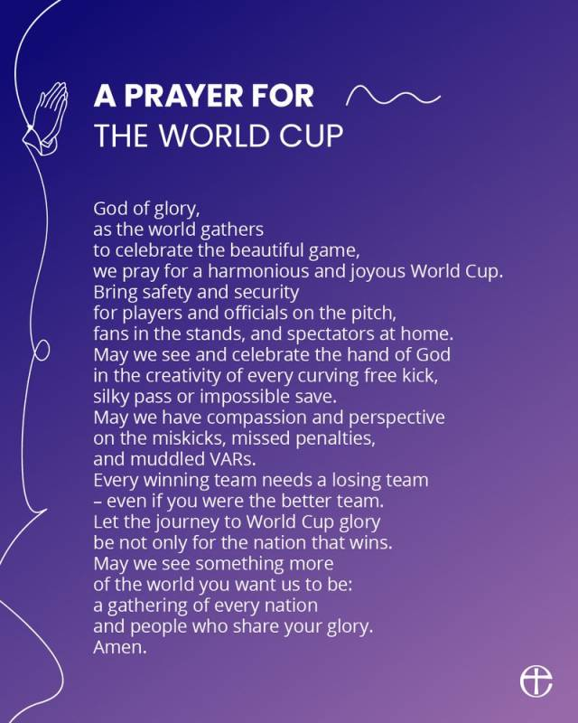

- Merciful God, Where we have erred, forgive us our foolish ways and pride, make us worthy of your name. help us to worship and serve you sincerely and lead us to do what is right. Guide us day by day and speak to our hearts through the night of the good we may endeavor to do in your name. Be near us through the whole of life so that nothing can shake our faith; show us the path that leads to life and let your Holy Spirit sustain us now and forever. Amen

